In the Kitchen for Solubility and Temperature!

Do this…

part I:
- get 2 cans or small bottles (of the same brand) of soda.
- place one in the fridge overnight
- leave the other on the counter [or in your room – someplace warm…]
- AT THE SAME TIME - pour both cans into separate clear glasses.
- compare the amount of bubbles in each (which one is fizzier)
- wait 10 minutes – now taste each - compare again which is fizzier now?

part II:
- get 2 clear glasses
- fill both about ¾ full with tap water
- place one in the microwave for one minute or so (til it’s hot)
**be careful – it will be hot - don’t burn yourself**
- drop one tablespoon of sugar in each glass
- stir each for about 10 seconds
- compare the amount of sugar at the bottom of each glass
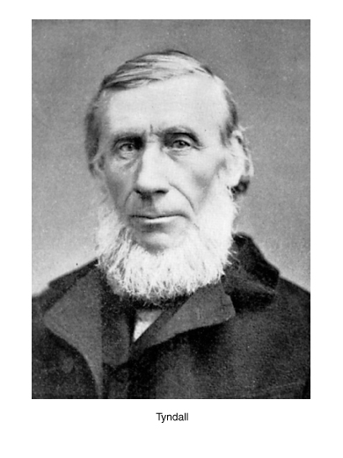

part III:
- get on the net… look up the Tyndall Effect
- design and carry out an experiment that demonstrates the Tyndall Effect
- draw a picture, photo or video your results

so…
- what is the effect of temperature of solubility of a gas in a liquid?
- what is the effect of temperature of solubility of a solid in a liquid?
- write your procedure for your Tyndall experiment.
- why did I include the Tyndall Effect in this assignment? (what does it have to do with solubility and/or solutions?)

