Vocabulary:

Proportional (α) vs.
Inversely Proportional (1/α)
Intrinsic property
Conduction
Convection
Radiation

Conductor
Insulator
Absolute zero
Kelvin/Celsius scale
calorie (cal) vs. Joule
Specific Heat
Calorimeter
Ideal gas
Phase Change
ΔT
Boyle’s Law
Charles’ Law
Conservation of M & E
Energy Transfer

Concepts:
- Boyle’s Law: what it states. Why it happens.
- Charles’ Law: what it states. Why it happens.
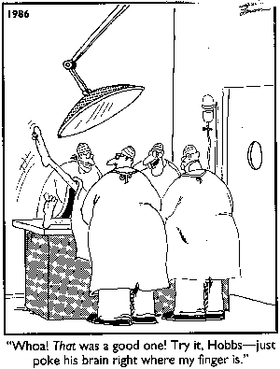
- Compare and contrast three methods of heat transfer
- Compare and contrast heat and temperature
- State Laws of thermodynamics we studied and real life examples of the laws in action
- Absolute zero: what it is and how it is derived
- Kelvin scale versus Celsius scale: what is each based upon?
- How heat is measured and what variables affect the heat contained in something
- Discuss why the graph on p 442 levels off (goes flat) for the intervals shown.
- Why did the surprise ending that Mr. Gedansky had NOT give you frostbite?
- What is specific heat? Is it an intrinsic property?
- Why is the book’s definition: “The ability of a substance to absorb heat energy is called its specific heat” a bad definition. Explain where it goes wrong and how it should be worded.

Equations/math stuff:
Heat gained/heat lost equation (word problems on p. 437)
∆T equation

Periods 5 and 7 only:
The specific heat lab and how the procedure relates to the SH equation
Calculating Specific Heat

