The Rope Problem

I. Objective: Separate two individuals joined together by two strands of rope

II. Directions:

- Tie a small loop onto the two ends of each rope. Do this such that you can slip the rope over your hands and onto your wrists.

- Person “A”: Take one of the lengths of rope and slip the loop of one side onto your right hand, the other loop onto your left.

- Person “B”: Take your rope and slip one of the loops onto your left hand. Next, pass the free end of your rope between your partner’s rope and his/her body. Last, slip the other loop onto your right hand. (see fig. 1)

CONGRATULATIONS!!
(you should be joined together)

- You may now attempt to separate yourselves; however, you may not:
a. cut the ropes
b. untie the knots
c. slip the loops off your hands

- Yes!!! It is physically possible!!!

- Write up your solution and all of the steps you took to arrive at it. Be very specific – Be so specific that you could separate a pair of people in the same predicament just by reading your directions to them. (that means: without pointing, helping, showing, using names, etc…) You should use steps – 1,2,3… do not try to write a paragraph.

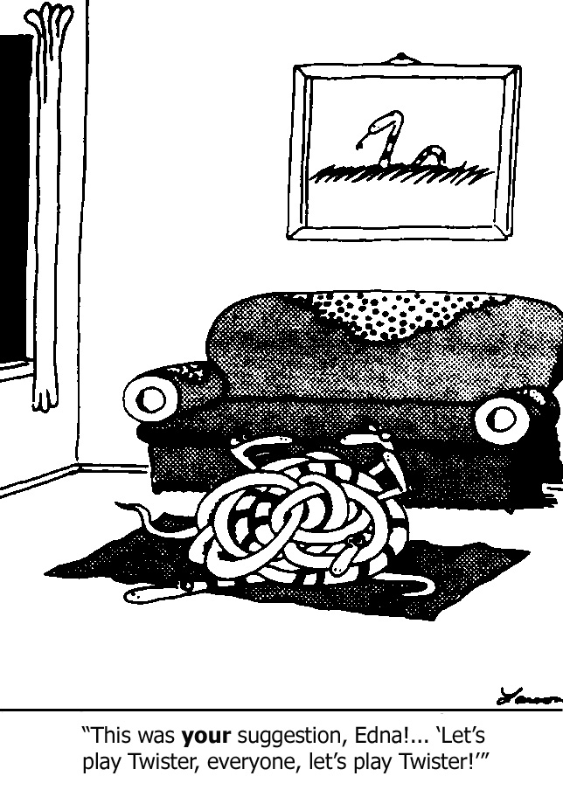
- GOOD LUCK!! (use the Force if you have the gift…)

