A Swingn’ Good Time w/ BOB the Rabid Pendulum…

A Pendulum: (see pic below) is a mass (called a bob) suspended from a cord that swings (you have used one of these before – in the Cellar Physics)
A Period: is the amount of time (in seconds) that it takes a bob to complete a full swing back and forth.
Your Job: Create a lab that will allow you to determine the following:
- how the mass of the bob affects the period
- how the length of the cord affects the period
- how the drop-height of the bob affects the period
What You Get:
- ring stand
- ring clamp
- string
- several masses
- stopwatch
- meter stick
Before you begin this lab you must state the following:
- Problem Statement w/ clear identification of IV & DV
- Procedure (describing a controlled experiment)
- Data Table
Stuff To Ponder:
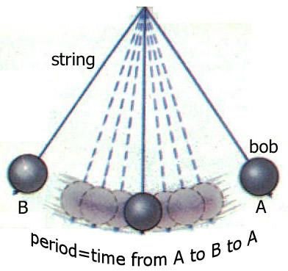
What is the best way to accurately time a period?
What forces are in action during the swing of the bob?

